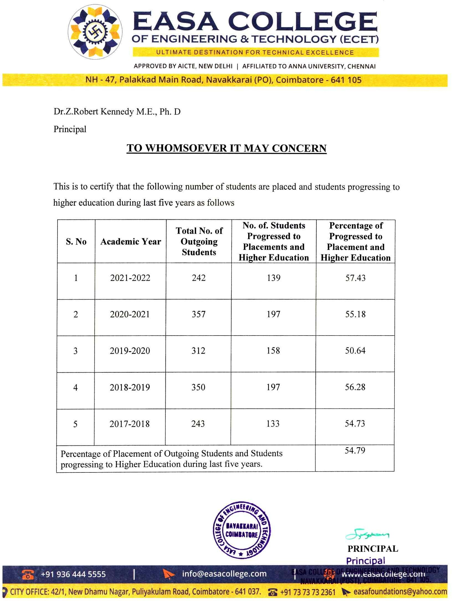



5.2.1 Percentage of placement of outgoing students and students progressing to higher education during the last five years.

S. No. | Details | Link to the relevant document
1 | Details of placed students and students  progressing to higher education during 2021-2022 | View File
2 | Details of placed students and students  progressing to higher education during 2020-2021 | View File
3 | Details of placed students and students progressing to higher education during  2019-2020 | View File
4 | Details of placed students and students  progressing to higher education during 2018-2019 | View File
5 | Details of placed students and students  progressing to higher education during 2017-2018 | View File

